The Garden City Casino Awarded USTA Private Club Award
The USTA (United States Tennis Association) has recently granted the Garden City Casino the prestigious “Private Club Award” for the Long Island Region.
The Casino was chosen for this award as a result of the active participation of its members in the Long Island tennis community. Their leadership efforts have brought tennis members together to raise funds for cancer organizations, in particular Charlie’s Champions for pediatric cancer and the Kaleidoscope of Hope Foundation for ovarian cancer.
In addition, the Casino’s Children’s Program was also recognized (among other reasons) as being one of the first, if not the first, program to incorporate the USTA's new Quick Start tennis format.
The award will be presented at the USTA LI Region Annual Dinner on May 9th at the Crest Hollow Club and will be accepted by Bill Mecca on behalf of the Casino.
For more information about the Garden City Casino and our complimentary trial membership for the month of May 2012 please:
- see our website TheGardenCityCasino.com or
- contact Brent Stranathan at 516-248-7006.
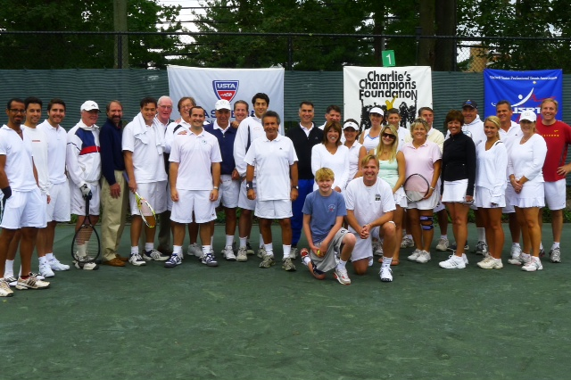
Members and participants at the Charlie’s Champions fundraiser.
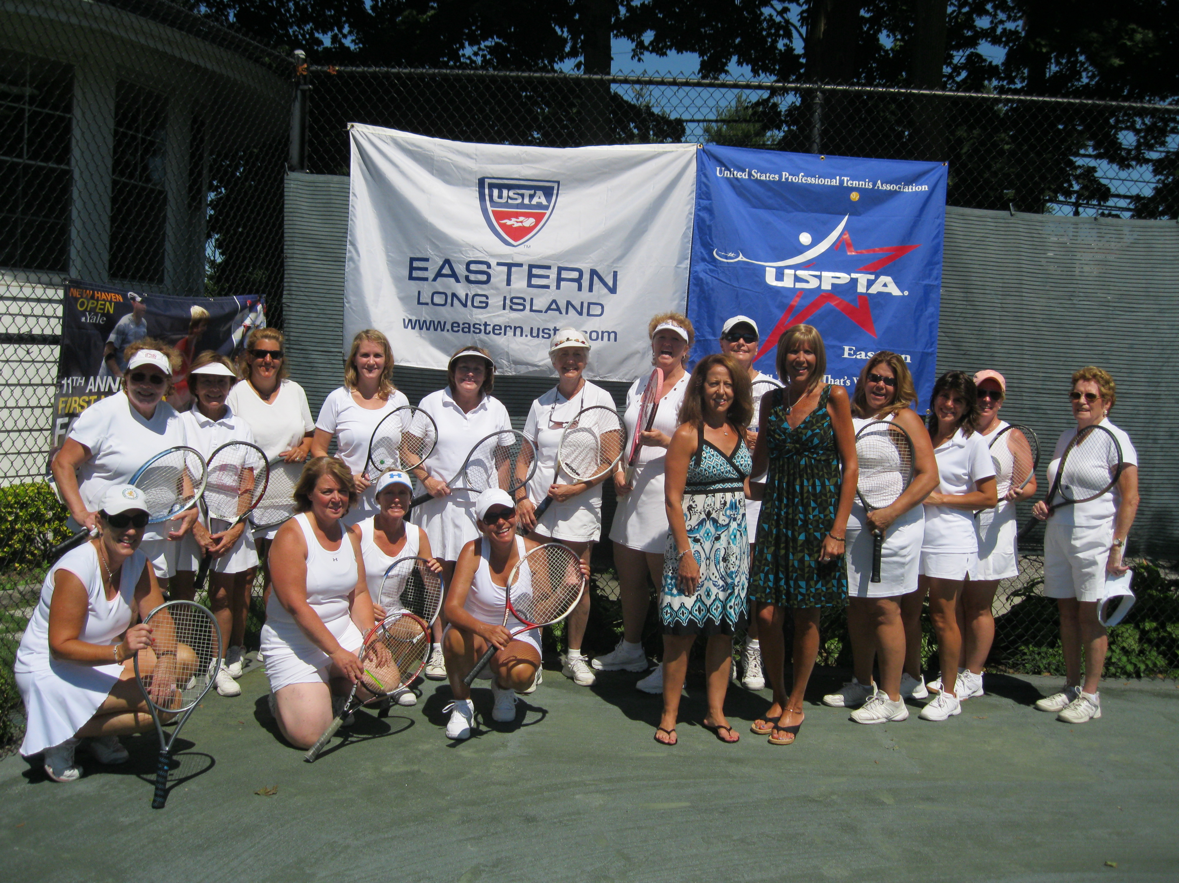
The tennis portion of the Kaleidoscope of Hope Foundation fundraiser.

